_-_-_-_-_-_-_-_-_-_-_-_-_-_-_-_-TEKENINGEN_-_-_-_-_-_-_-_-_-_-_-_-_-_-_-_-_-_-_-_-_-_-_-_

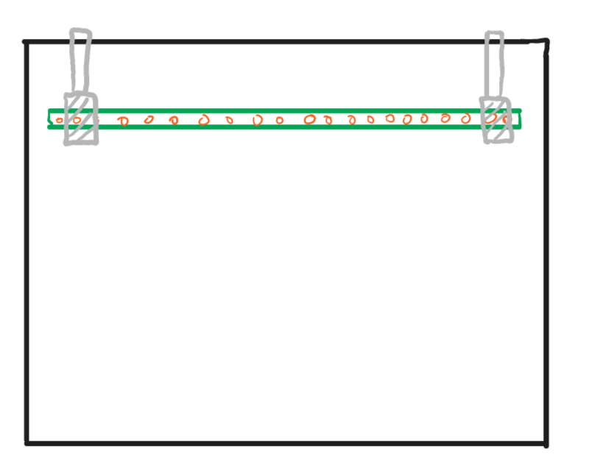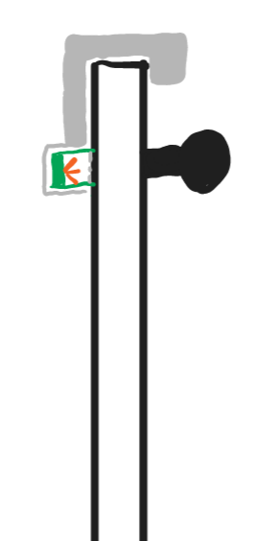

_-_-_-_-_-_-_-_-_-_-_-_-_-_-_-_-_- INFO_-_-_-_-_-_-_-_-_-_-_-_-_-_-_-_-_-_-_-_-_-_-_-_

32 meters of length

28 poles (A-B) → 9 voor 10 meter test

-<https://quinled.info/addressable-digital-leds/#DigitalBuy>

_-_-_-_-_-_-_-_-_-_-_-_-_-_-_-_-_- DEEP thoughts -_-_-_-_-_-_-_-_-_-_-_-_-_-_-_-_-_

* Already trailing light
* Lighting up the panell where a sensor (person present) is activated
* More than 8 sensors sensing the whole line firework
* When there are two people going to each other when they meet a big explosion
* BOEMMMM zone grote vuurbal (school weg) haha grapje met de leds he ;)...Of toch niet
* adding sound? (depended on the speed?????????????)

_-_-_-_-_-_-_-_-_-_-_-_-_-_-_-_-_- TROUBLES -_-_-_-_-_-_-_-_-_-_-_-_-_-_-_-_-_

* Power? Hoe verdelen? Genoeg amp voorzien?

_-_-_-_-_-_-_-_-_-_-_-_-_-_-_-screen saver animations -_-_-_-_-_-_-_-_-_-_-_-_-_-_-_-_-_

* Snake
* Snowflake (in colors)
* Fireworks
* Random pulsen op de lijn (t-bo achtergrond)
* Hart rate in stukken van de lijn.

| Apparaat | Price | Beschrijving | Link |
| --- | --- | --- | --- |
| ARGB 5m 5050  WS2811ALL | 2 * € 17,65 per 5m | Geeft licht | <https://www.amazon.de/WS28115M60LB30-WS2811ALL/dp/B01CNL6K52/ref=sxin_16_pa_sp_search_thematic_sspa?content-id=amzn1.sym.433505b2-cb41-4afd-b8ac-996325a82a2b%3Aamzn1.sym.433505b2-cb41-4afd-b8ac-996325a82a2b&crid=3L7MGZ5A2I0RZ&cv_ct_cx=ws2811%2Bled%2Bstrip&keywords=ws2811%2Bled%2Bstrip&pd_rd_i=B01CNL6K52&pd_rd_r=30d52fa3-4599-4355-ad4f-658c2886e910&pd_rd_w=MYcjw&pd_rd_wg=efH31&pf_rd_p=433505b2-cb41-4afd-b8ac-996325a82a2b&pf_rd_r=MFJMVE7JJMR74JTZAJ4G&qid=1676562885&sprefix=ws2811%2Bledstrip%2Caps%2C106&sr=1-1-6e6ea531-5af4-4866-af75-1ef299d1c279-spons&sp_csd=d2lkZ2V0TmFtZT1zcF9zZWFyY2hfdGhlbWF0aWM&th=1> |
| ‘goot’ | 3,79 per 250cm  10 meter → 4x | -goedkoper dan plastiek  -zal niet buigen zoals plastiek (straight line) | <https://www.gamma.be/nl/assortiment/hoekprofiel-gegalvaniseerd-2-5m/p/B882154> |
| cPIR Sensor | 10 * 2,49 | – Detectie afstand: 3-7m.  – Vertraging: 5-200s  – Output voltage: 3.3V  - Werkt op: 4.5-20V  – Detectiehoek: <140°. Kunnen dit verminderen met  De gedrieprinte behuizing | <https://www.otronic.nl/nl/pir-sensor-hc-sr501-bewegingssensor.html?source=googlebase&gclid=Cj0KCQiAxbefBhDfARIsAL4XLRoYonEozP9M0mI9uaDadXxXTdLETMqjRJls5CX4HUkRmok3SzswtZQaAhkNEALw_wcB> |
| Infrared Emitter | **10 * 0,162 €** | Infrarood emmiter | <https://be.farnell.com/multicomp/ofl-5102/infrared-emitter-940nm-t-1-3-4/dp/1716710> |
| Phototransistor | **10 * 0,94 €** | Phototransitor | <https://be.farnell.com/vishay/bpv11f/phototransistor-t1-3-4/dp/1045379?ost=1045379> |
| ESP | **2 * 9,89 €** | Compatible with Wled | <https://www.otronic.nl/nl/esp32-wroom-4mb-devkit-v1-board-met-wifi-bluetooth.html> |

Planning

|  | BESCHRIJVING | Occupants |
| --- | --- | --- |
| Week 1 | Infrabel aszsholes, was wel goeie burgur tho. thompie op insta gekomen | all |
| Week 2 | Alle onderdelen bestellen, weten hoe we het probleem zullen oplossen | all |
| Week 3 | software/hardware symbiose + concept of working prototype |  |
| Week 4 | Een kleine prototype bouwen (1-2 sensors, paar leds) + 3d prints design | 3d (Thomas) |
| Week 5 | Trouble shooting klein prototype bouwen + kijken voeding alternatief + 3d maken |  |
| Week 6 | Groot prototype bouwen + voedingsproblemen oplossen + 3d printen + concept of how it works |  |
| Week 7 | 3d prints moeten af zijn. |  |
| Week 8 | Installeren van alles op juiste locaties |  |
| Week 9 | Werking project volledig + bakje animaties installeren |  |
| Week 10 | Powerpoint moet af zijn + animations maken + vollediging af |  |
| Week 11 | Filmpje moet af zijn. + animations maken |  |
| Week 12 | Final checks |  |

